**Part I – How to install and set PostgreSQL and Pgadmin4.**

PostgreSQL:

1. Download Postgres Installer [here](https://www.enterprisedb.com/downloads/postgres-postgresql-downloads).
2. Click on the executable file to run the installer.
3. Select your preferred language.

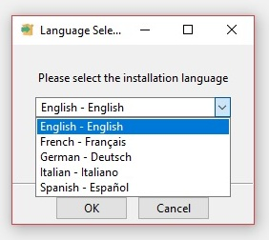

1. Specify the directory where you want to install PostgreSQL.
2. Specify PostgreSQL server port. You can leave this as default if you’re unsure what to enter.  
   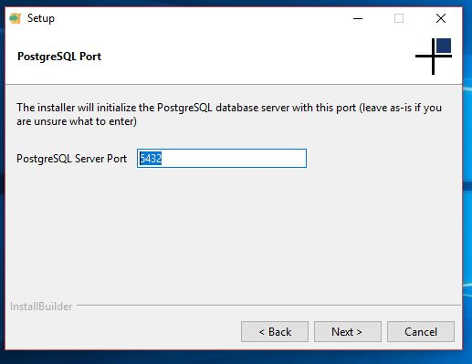
3. Specify data directory to initialize PostgreSQL database.  
   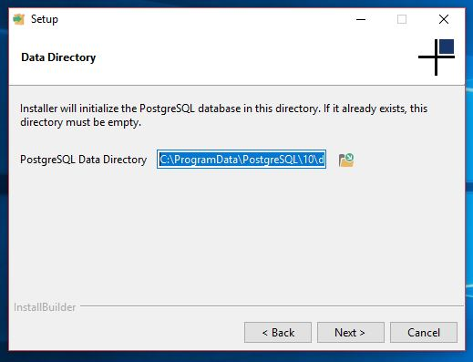
4. Create a PostgreSQL user password.  
   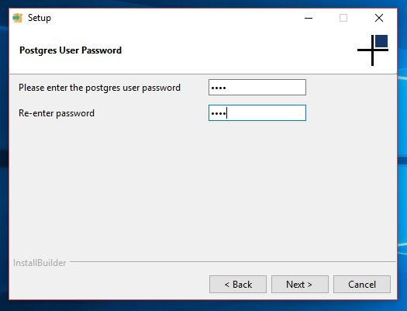
5. Create a password for the database Superuser.  
   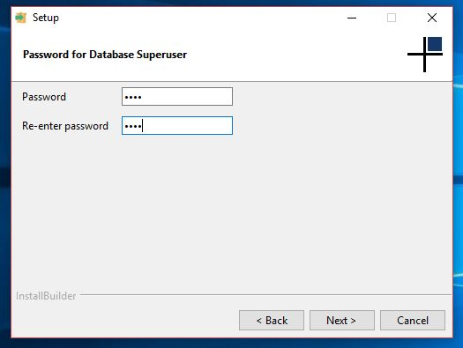
6. Click next to begin PostgreSQL installation.

Pgadmin4 installation:

1. Download Pgadmin4 Installer [here](https://www.pgadmin.org/download/pgadmin-4-windows/).
2. Now the pgAdmin 4 installer is up. Click Next:  
   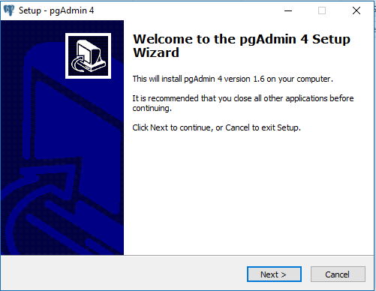
3. The wizard will then ask you to read over the license agreement. You should agree and accept. Then click next.  
   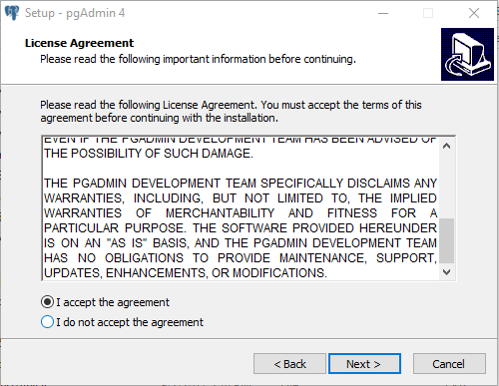
4. It will then ask where you want to save your program files for pgAdmin 4. I keep it in the default/suggested folder. Once done, select next:  
   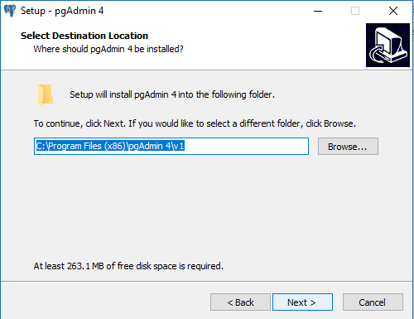
5. Now it will start installing  
   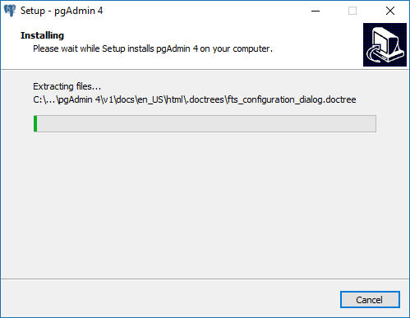
6. When it’s done installing, you can select Launch pgAdmin 4 and Finish  
   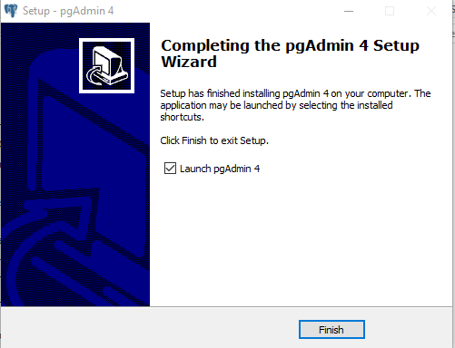
7. pgAdmin 4 may take some time to launch, and when it does, it will look something like this:  
   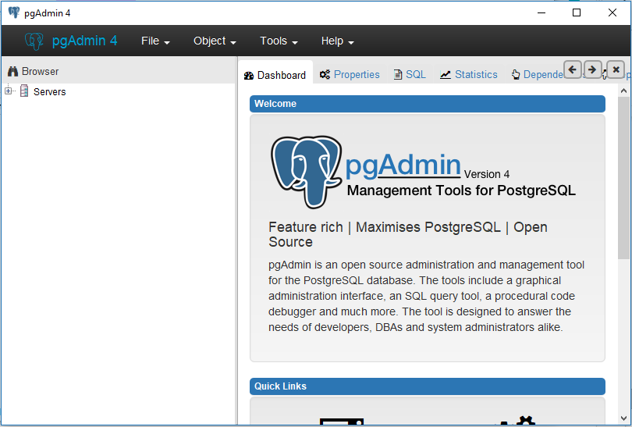
8. There will be a default PostgreSQL server on your system. You can access it on pgAdmin. On the left-hand Browser, click the + next to Servers, and it will show the server. It will name something like PostgreSQL xx.xx. Type in the password(Already done before).  
   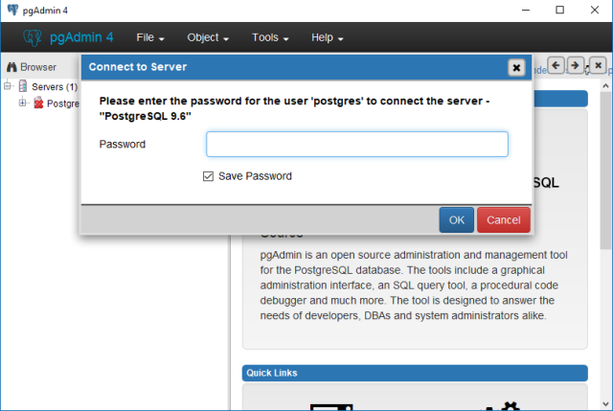
9. Using pgAdmin 4, you can now explore your PostgreSQL server that hosts your database. It will be pretty empty.
10. Create a new database, right-click it, select backup:  
    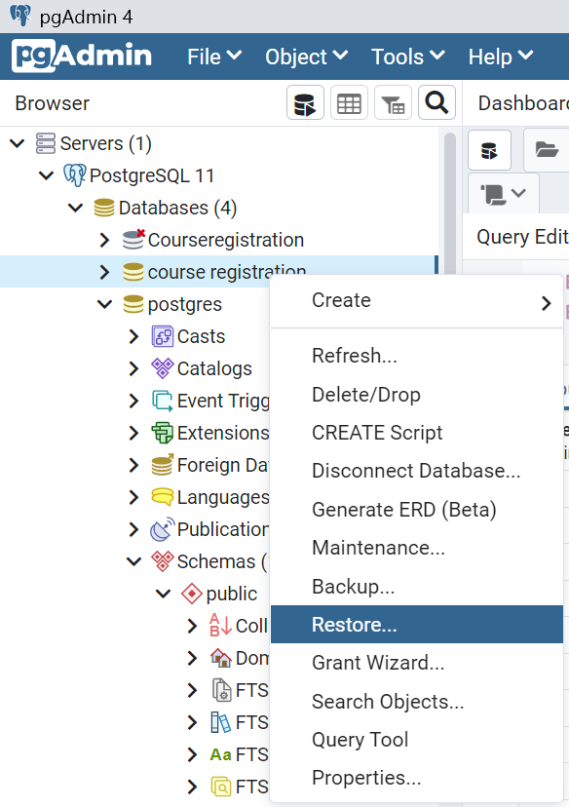
11. Click the ...right after Filename:  
    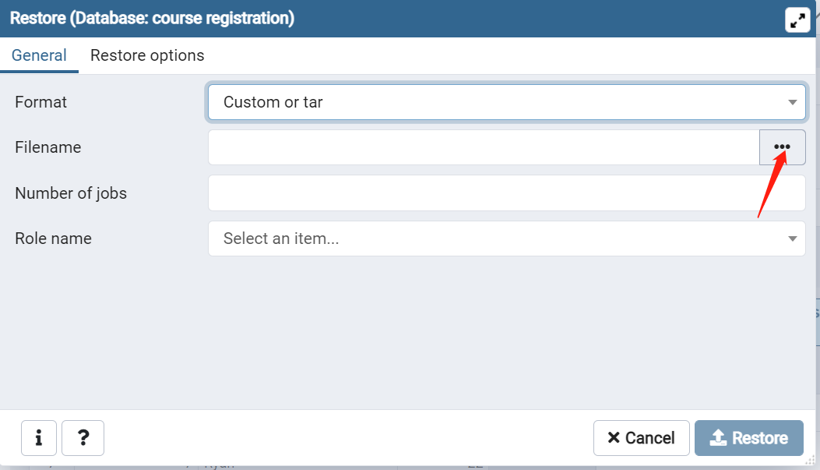
12. Select the file courseregistration.sql, and then we are done.

**Part II– Tables**

College**:** Includes college ID, college names, and college addresses as follows:

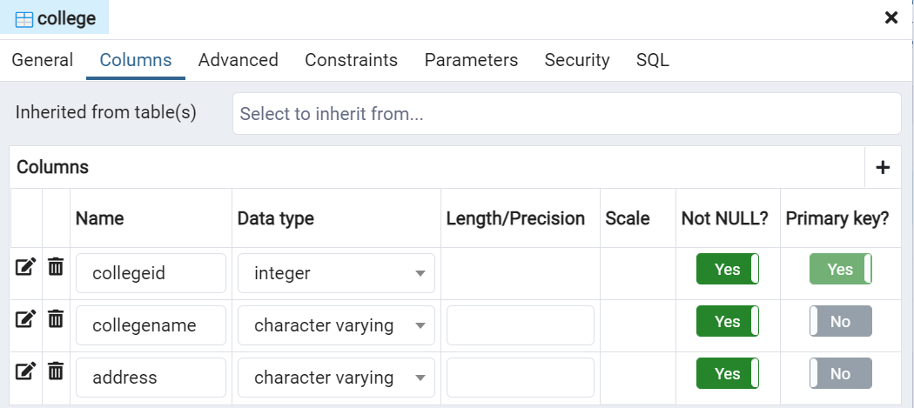

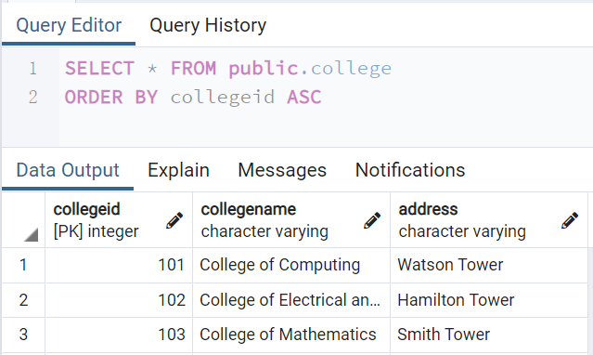

Department: Includes department IDs, department names and corresponding college IDs, a college contains at least one department.

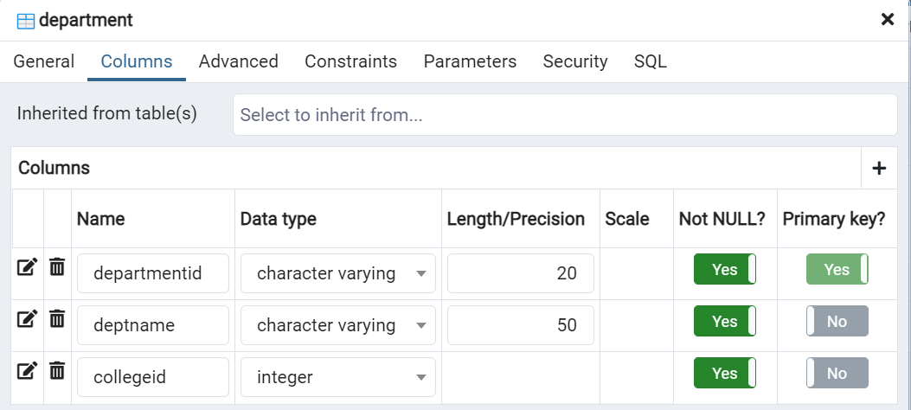

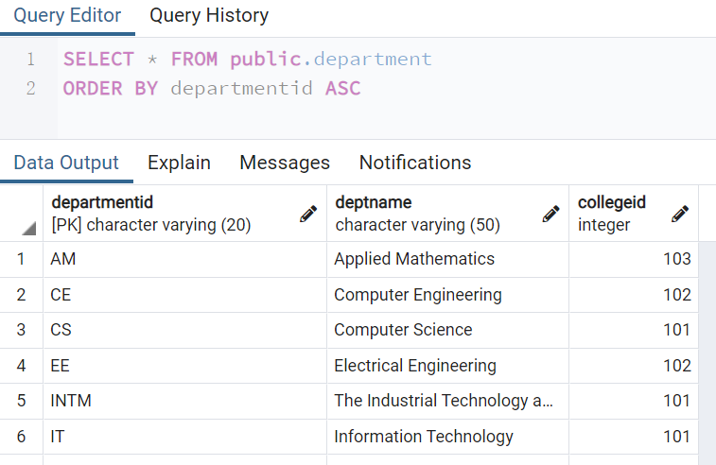

Course: Shows courses’ information. Includes course IDs, names of these courses, credits and hours per semester:

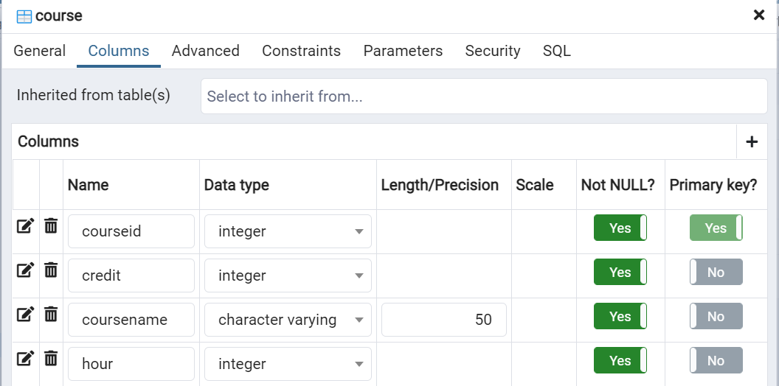

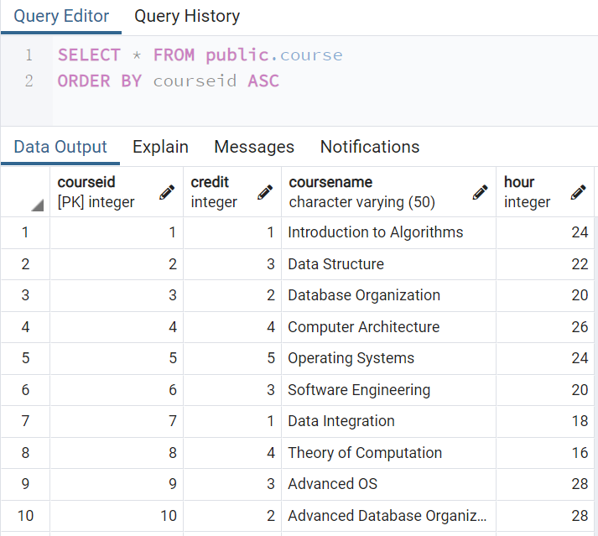

Student: Shows students’ information which includes student IDs, students’ names and their ages.

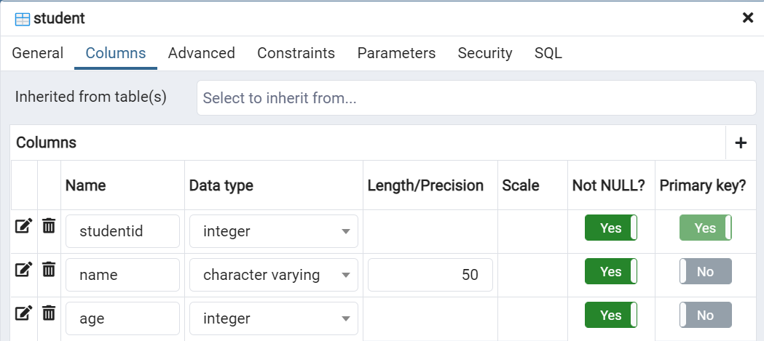

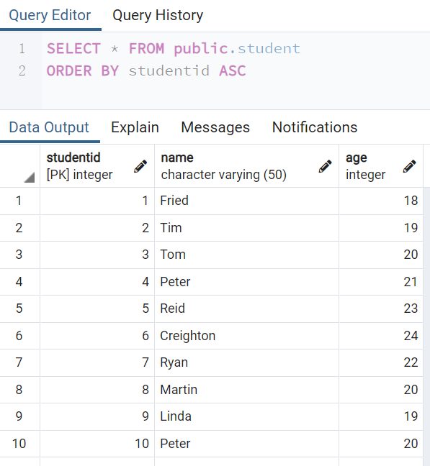

Section: The table section describes the detailed information of courses for students to choose, which includes section IDs, classrooms and dates/time for courses, and corresponding courses’ IDs and instructors’ IDs.

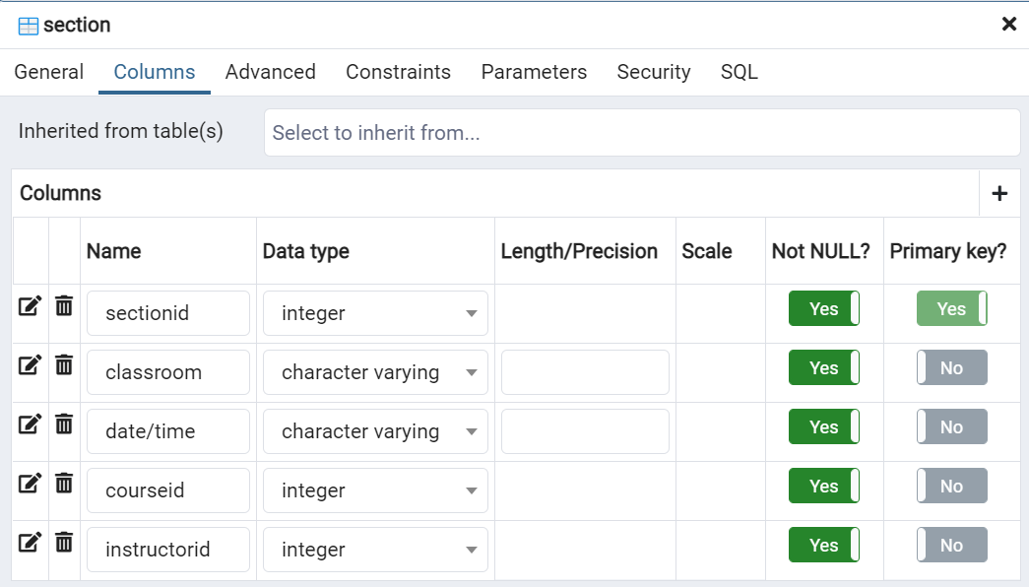

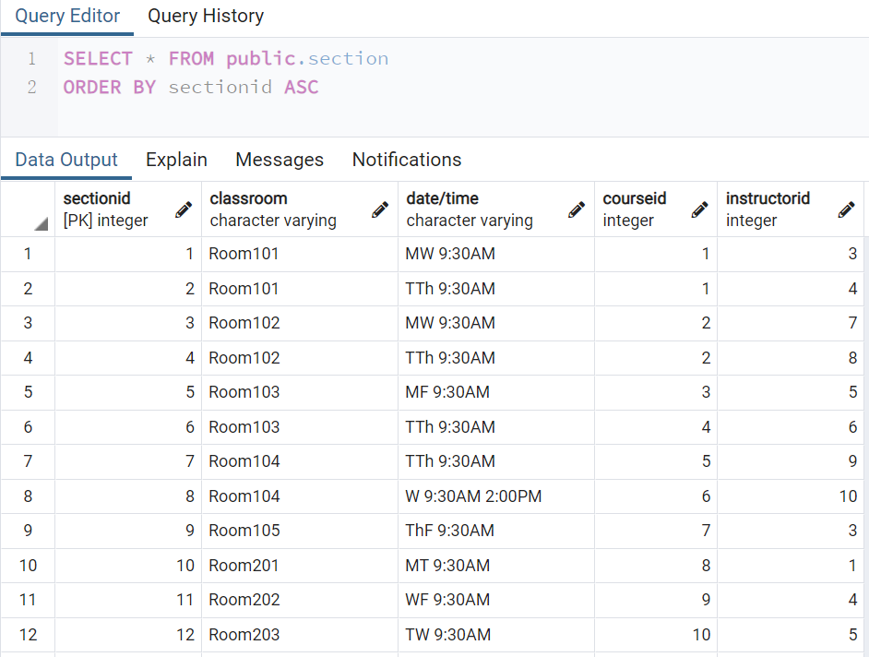

Registration: This shows the registration status of students. Contains registration IDs, type of the students(student/audit), student IDs and section IDs.

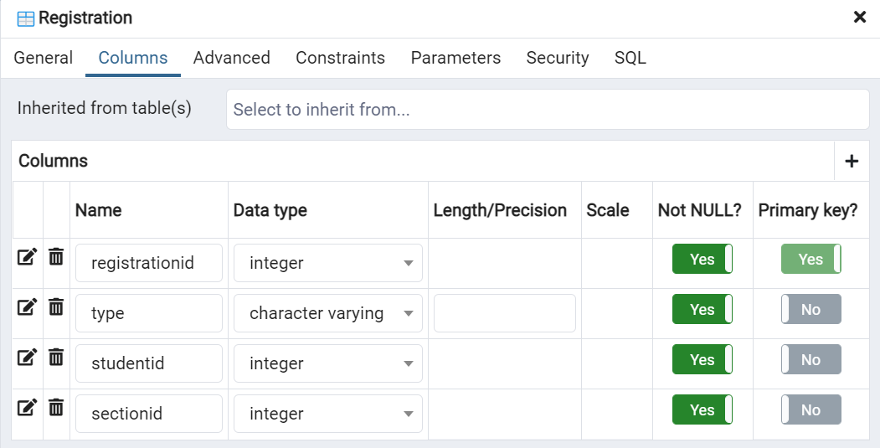

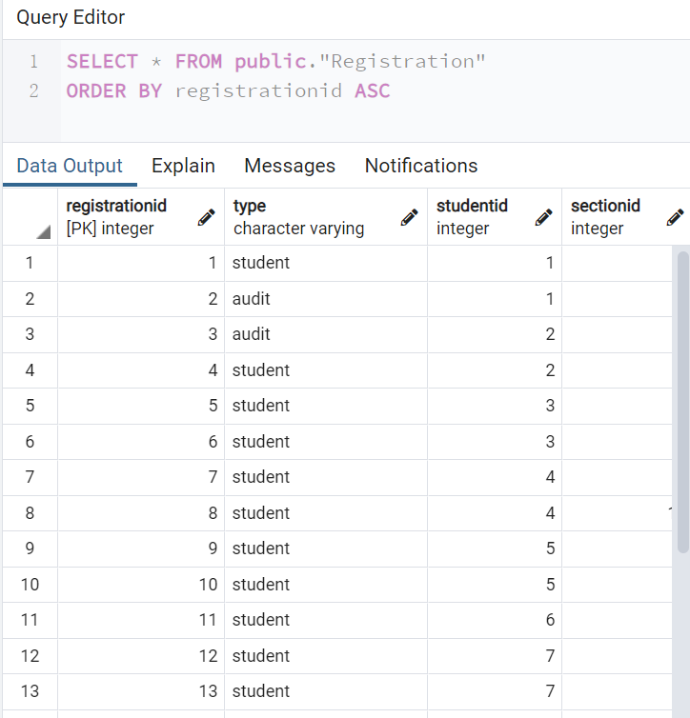

**Part III– How to do queries by PgAdmin 4:**

1. **Find tables, right-click it and select Query Tool:**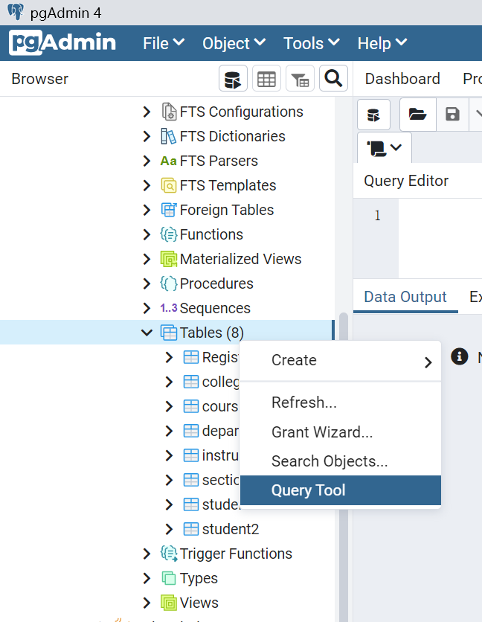
2. **Type in query commands in the Query Editor section.**For example, If you want to select all the fields available in the table student, use the following command, and then click the execute button as the red arrow point at: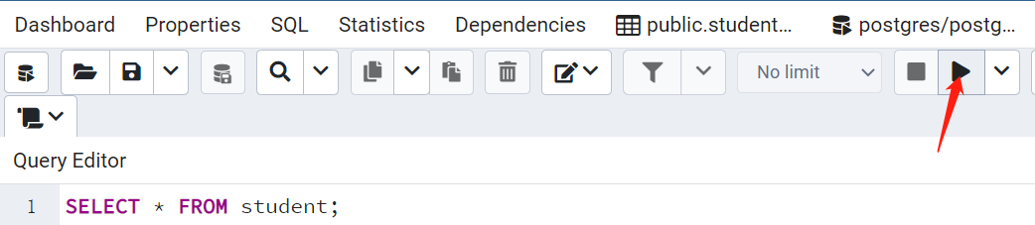  
   Then we can see the whole table student: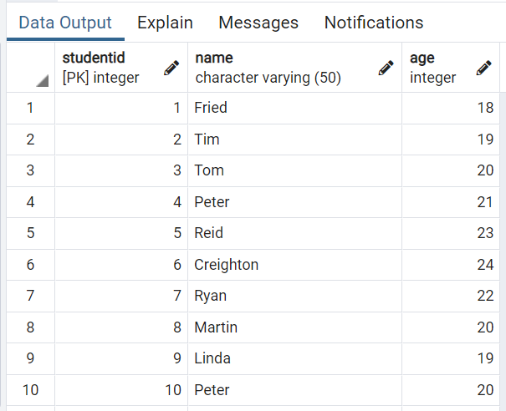
3. **More query examples:**Delete all the students with ages above 20 from student2(which was a copy of table student):  
   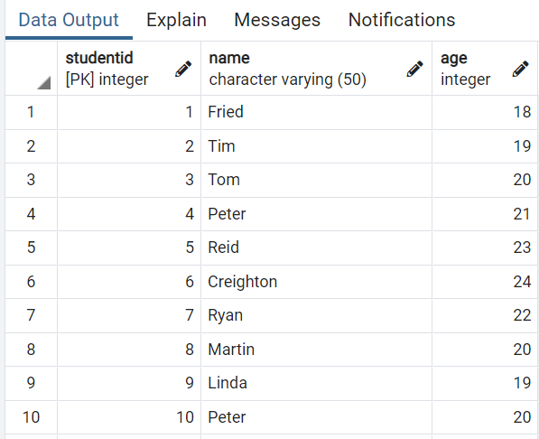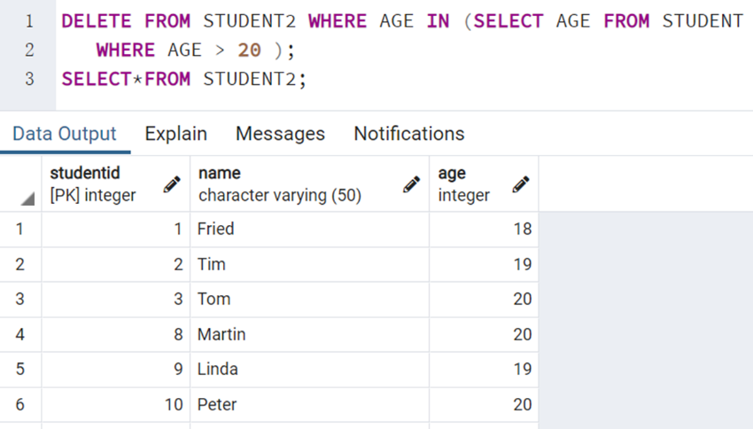  
   UPDATE student2(change name Tom into Thomas):  
   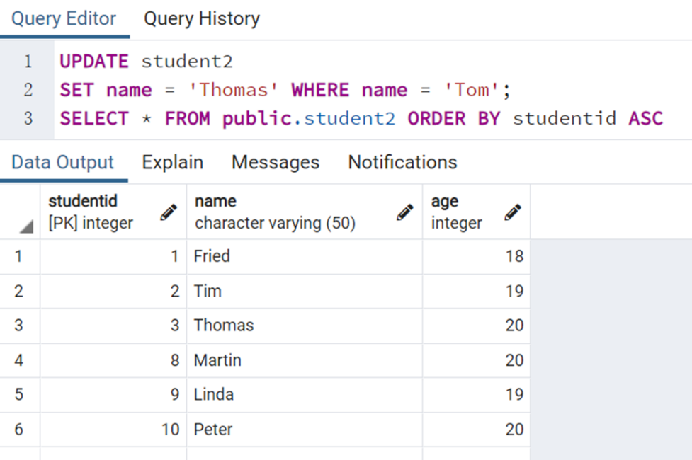  
   List courses with credits larger than Database Organization:  
   